The Mental Effects of the Treatment of Women

Alyssa M. Bolander
ENG 2040-01: Great Books in Literature
Wright State University

Abstract
Greek mythology has always had a great impact on our culture in many ways, as many trends that are present in Greek mythology are present in our daily lives today. We have adapted many themes and ideas from Greek mythology, and a lot of them still occur today. The most notable theme that can be observed throughout the course of our readings this semester is the treatment of women in Greek mythology.
Keywords: Greek mythology, women

The Mental Effects of the Treatment of Women
The treatment of women during Greek mythological times was very negative in many aspects. Women had little freedom, and there were double standards set when it came to marriage, sexuality, employment, and social aspects throughout their lives. Ancient Greece was organized both socially and politically to benefit males. Male power in the patriarchy dominated society, as well as their doubt about women’s abilities. Men were painted as powerful and dominant, whereas women were painted as shameful, and responsible for the downfall of everything. Sadly, many of these aspects are still present in some ways in our society today. Some forms of oppression that women still face today include the gender pay gap, the remaining prevalence of double standards in terms of marriage and in terms of sexual partners, abusive relationships, and women being taken advantage of. Throughout this paper we will explore these occurrences and the lasting effects that each of these instances leave on women, their prevalence today, and their relation to Greek mythology readings throughout the semester.
In many of the Greek Mythology tales that we read we can further note the lack of power of women as they are sexually assaulted against their will. An example of this in our readings is when the daughter of the last king of Troy was nearly raped by a Greek soldier in the Tenoke of Athena. A second example is when Circe is raped by a ship captain from a ship that seeks refuge on her island. She then turns the captain and all the men into pigs in order to get back at them. Though this is not real life, and we cannot simply solve our problems by turning men to pigs (although it would be nice) this displays the mental struggle that she faced after this tragic occurrence. The lasting effects of rape can have a serious effect on one’s brain including depression, flashbacks and PTSD, as well as dissociation and panic attacks. In today’s society, we are equipped with many resources to help sexual assault survivors receive the support that they need. Though we still have a great amount of improvement to make, we have made several leaps and bounds compared to the non-existent resources that would have been present during Greek mythology times. Because ideas of rape and abuse with little to no punishment were present then, we still see them in our society today sadly. For example, Brock Turner, who received barely any punishment for his rape of a female on campus. Having little punishment makes these men continue to believe that they have power and that there are no consequences for their actions.
The gender pay gap is another instance that was brought about because of Greek mythological times like those that we read this semester. During ancient Greek times, women were not allowed to do the work that men did. They were responsible for bearing children and other household responsibilities, however, holding a job was not one of these responsibilities. Not having a job and being at home almost all of the time can have a lasting effect on one's brain and sanity. Not holding a job can create feelings of self-doubt. These feelings can cause anxiety and depression in individuals, which has a lasting effect on one's brain. Today, women hold many of the same jobs that men hold and excel in a diversity of fields. However, because of past beliefs and gender roles, there is a gender pay gap. For every dollar a man makes, a woman makes eighty-two cents. This statistic can lead to feelings of self-doubt and little self-worth. If you are working just as hard as someone else, maybe even harder, then why are you not receiving the same pay as that other individual except for that you are just simply not the same gender as them.
Throughout our readings during the semester, we saw many abusive and unhealthy relationships that included infidelity and double standards. Today there is still a double standard in terms of having sexual relations with others. Men are high-fived and congratulated by friends when they share how many women they've slept with, but when women share that they've slept with multiple partners, they are looked down upon and slut shamed. One may ponder why this occurs but there is a simple explanation. It is because in Greek mythology, nobody questioned when men slept with a multitude of women or had affairs, which is why it still occurs now. Adultery and sleeping with others outside of marriage closely relates to the idea of abusive relationships. Abusive relationships were present then, as mentioned previously, but also still present now. For example, the case of Gabby Petito and Brian Laundrie, an abusive relationship that led to the death of both partners. Since abusive and unhealthy relationships were present in past times, they are still present in some cases in today's society. An abusive and/or unhealthy relationship can contribute to many mental health effects such as, depression, anxiety, and PTSD. This still holds a presence in society today in cases like Gabby Petito and her demise caused by her ex-fiance. Because bad and unhealthy relationships were okay then, that is why they are still somewhat prevalent now. A relationship like this can have a multitude of effects on individuals including low self-esteem, depression, anxiety, PTSD and increased risk for developing an addiction to drugs and alcohol.
Women had very few choices in the occurrences in their lives, and this certainly led to a lasting negative psychological effect. Women were, and still are in many cases, used, taken advantage of, and treated poorly overall. Further examples of women being treated poorly throughout our readings include how Odysseus captures the women from Ismarus in a raid to turn them into slaves, and how the son of Odysseus is assumed to take over the role of Ithaca after his father has not returned for a long time rather than his wife (this was customary in this time because of the patriarchy). Another example of poor treatment and representation of women is how they are often seen and used as objects; like in the start of the Trojan war, Polyxena being gifted to Achilles. The list of mistreatment goes on and on, and time and time again women are treated poorly and taken advantage of. These low and negative opinions of women contribute to our society's treatment of women today.
Though women now hold much more power and many more rights than they did in past times, we still have a long way to go. In 2021, in the United States, we still have a gender pay gap, men raping women with little to no consequences for their actions, abusive relationships, and jobs that are predominated by males (this may be because many individuals still have old-school beliefs that women should stay home and take care of the house and family, rather than work). All of these factors come about through the ideas that were presented in Greek Mythology. The negative connotation and sociological standards that were set then, are still present now, leading to many mental health concerns for women world-wide. Many women struggle with anxiety and depression due to these standards and acquisitions. Bringing up mental health concerns in ancient Greek time would have caused women to have been looked down upon even further. They were living in a time of no resources, no therapy, nothing. They simply had to deal with their trauma and horrible lives on their own. Luckily, today women (and men) now have many more resources available to help treat mental illnesses that may be brought about by these negative views of women.
Overall, how women are treated in Greek Mythology certainly still shines through in how women are treated today. Luckily, women now have many more resources to turn to when they are faced with unwanted ridicule. Beliefs that were held then, are certainly still reflected in how we treat women now. This can be seen through the gender pay gap, little to no reprimands for raping a woman, like Brock Turner, abusive relationships, like Gabby Petito and Brian Laundrie and so much more. Though we have made great progress since Greek mythological times, we still have much work to be done in order to give women the proper representation that they deserve. Our readings this semester highlighted many problems within the society of ancient Greek mythological times, including the mistreatment of women. This highlighted theme allows for us to pause for reflection and realization that in ways many of these acts are still occurring. I hope that with this report, and the awareness being brought about by people around the world that women will one day have completely equal rights to men, and that both parties receive adequate mental health treatment. 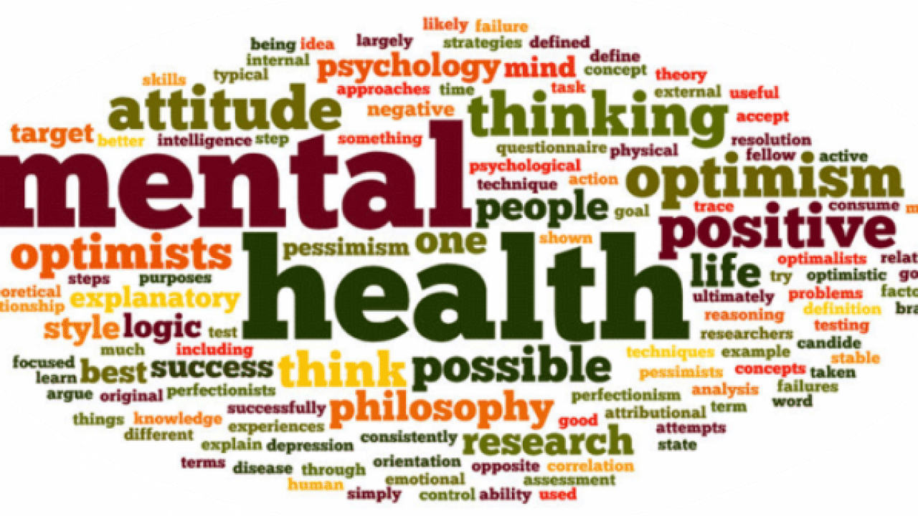

References
Atwood, M. (2019). Penelopiad. GROVE.
Beard, M. (2017, May 11). A pair of updated Greek tragedies startle us anew. The New York Times. Retrieved December 3, 2021, from https://www.nytimes.com/2017/05/11/books/review/house-of-names-colm-toibin-bright-air-black-david-vann.html.
Christa Wolf's Cassandra: Different times, different views. Society for Classical Studies. (n.d.). Retrieved December 3, 2021, from https://classicalstudies.org/annual-meeting/147/abstract/christa-wolf%E2%80%99s-cassandra-different-times-different-views.
Cowan, A., Ashai, A., & Gentile, J. P. (2020, January 1). Psychotherapy with survivors of sexual abuse and assault. Innovations in clinical neuroscience. Retrieved December 3, 2021, from https://www.ncbi.nlm.nih.gov/pmc/articles/PMC7239557/.
Fagles, R., & Stanford, W. B. The oresteia. Penguin.
Grinberg, E., & Shoichet, C. E. (2016, September 3). Brock Turner released from jail after serving 3 months for sexual assault. CNN. Retrieved December 3, 2021, from https://www.cnn.com/2016/09/02/us/brock-turner-release-jail/index.html.
Mason, Z. (2011). The lost books of the odyssey. Vintage.
Mental health statistics: Domestic violence. Mental Health Foundation. (2020, January 16). Retrieved December 3, 2021, from https://www.mentalhealth.org.uk/statistics/mental-health-statistics-domestic-violence.
Miller, M., & Horn, M. van. (2021). Circe. Uitgeverij Rainbow.
National Domestic Violence Hotline. The Hotline. (2020, December 15). Retrieved December 3, 2021, from https://www.thehotline.org/.
​​Priyamvada, P. (2017, October 5). Tracing the origins of rape culture in mythology. Feminism In India. Retrieved December 3, 2021, from https://feminisminindia.com/2017/10/06/origins-rape-culture-mythology/.
Rosman, K. (2021, September 21). How the case of Gabrielle Petito galvanized the internet. The New York Times. Retrieved December 3, 2021, from https://www.nytimes.com/2021/09/20/style/gabby-petito-case-tiktok-social-media.html.
Tóibín, C. (2018). House of Names. Penguin Books Ltd.
U.S. Department of Labor Blog. Home | U.S. Department of Labor Blog. (n.d.). Retrieved December 3, 2021, from https://blog.dol.gov/.
​​Walcot, P. (1984). Greek Attitudes towards Women: The Mythological Evidence. Greece & Rome, 31(1), 37–47. http://www.jstor.org/stable/642368
Wolf, C. (2011). Cassandra. Edizioni e/o.

